A view from  Latchford Medical Centre’s  Patient Participation Group  Meeting date: 27.11.2024 | 
Welcome to our Patient Participation Group’s (PPG) November newsletter, where we share updates, insights, and ways to keep the Latchford Medical Centre community informed and involved in our healthcare services.

What’s new at Latchford Medical Centre?

Patients can now submit administration requests and order their repeat prescriptions online 24 hours a day, 7 days a week using the link below

Latchford Medical Centre admin requests

What’s happening in the Latchford Community?

Keep up to date with what is happening in and around Latchford by following our Facebook page

 Latchford MC Facebook Page
Appointments update for October?

1610 eConsults were submitted and completed at Latchford Medical Centre in October 2024
4m 26s was the average queue time for telephone calls to be answered at in October 2024
267Patients did not attend their appointment at in October 2024.

It’s important to let us know if you cannot make your appointment so we can offer it to someone else in need. Let’s work together to keep healthcare accessible to everyone!

What’s Happening in South Warrington Primary Care Network?

Since October, the five practices in the South Warrington Primary Care Network (SWaN) have protected 1234 patients against Covid this winter. We have now finished our COVID campaign for 2024.


In October 2024, 134 patients responded to the question:
“How likely are you to recommend us to your friends and family?”
We’re delighted that 87% of those who participated in the Friends and Family Survey said they were extremely likely or likely to recommend our services to others.

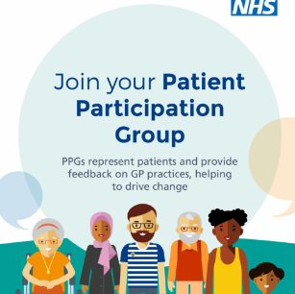
We’re looking to grow our Patient Participation Group (PPG)!

A PPG is a team of patients, carers, and staff who meet to share ideas, discuss patient experiences, and help improve our services.

We usually meet for an hour on the last Friday of each month at 2 PM.

Interested? Call us on 01925 637508 to join!

